**Table Smart Editor Documentation**

By Devin Rue

**Table of Contents:**

1. General Usage
   1. Basic
   2. [Example “Search” usage](Search#_Example_)
   3. [Example “Apply composed filter” usage](Apply_composed#_Example_)
   4. Adding or Editing a Record
   5. File Uploading
   6. ntext Data Type and Tiny HTML Text Editor
2. TSE Users
   1. Users
   2. User Profiles
3. Web.config
   1. TabMenuVoices
   2. InsertTabRelation
   3. TabsFormDati
   4. Detail Table
   5. Brief overview of other noteworthy Web.config settings
4. Edited Files
5. SQL Data Types Compatible with TSE
6. Bugs

# \\Crabdata2\data\Staff\DevinR\docimages\login.PNGGeneral Usage:

## Basic:

-You start on a login page, where you enter your username and password to continue

-Note that your password **as well as username** are case-sensitive

-Once logged in, the tables available to your user will be categorized in tabs along the left of the page

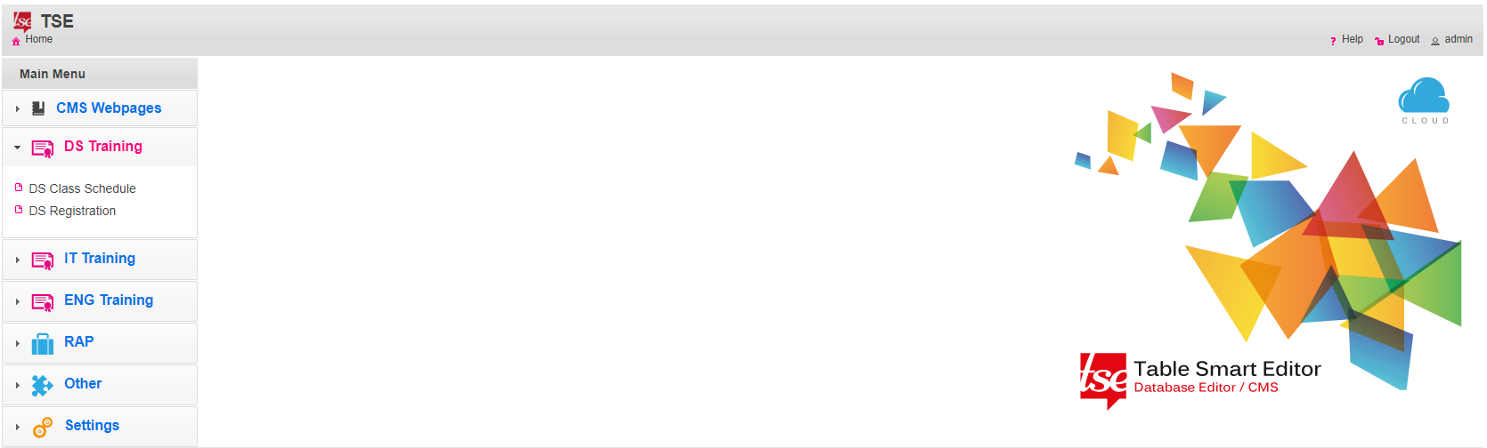

-Navigate to a table, and you will see the following interface:

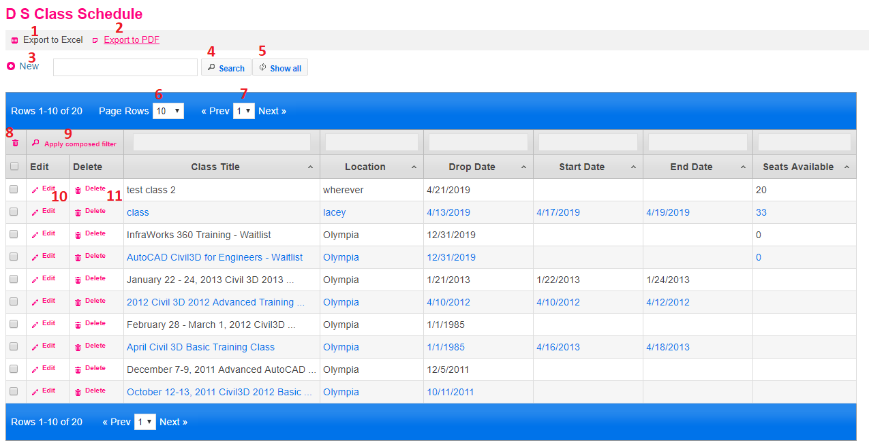

Key:

1. Saves a copy of the table as an Excel spreadsheet
2. Saves a copy of the table as a PDF
   1. This is dependent on WKHtmlToPdf, which was installed on the dev server TSE is on. Should this be a problem, this can be uninstalled and the button can be hidden
3. Directs you to a form to enter a new record into the table
4. Performs a search on the table based on the contents of the textbox, returning records where a match is found in any column
5. Resets table to show all records
6. How many rows to display on a single page
7. Navigate to a specific page
8. Performs a delete on all rows that have the checkboxes below checked
9. Filters shown rows based on values entered in the textboxes above each column
   1. **NOTE: Hitting the Enter key will simply reset all searches/filters (as if you clicked “Show All”). You must click “Apply composed filter” for this to work**
   2. **It’s picky about dates, you must use a range.** As of now, it currently brings up a datepicker that will not work because it uses dd/mm/yyyy format. You can still make this work by manually typing in a date range, in the format of “mm/dd/yyyy – mm/dd/yyyy”. For example, 6/10/2019 – 6/15/2019
   3. It should work in most other cases. If seemingly nothing happens, then it may be because the data type is one TSE arbitrarily can’t search with (like smallint)
10. Directs you to a form to edit the associated row
11. Directs you to a form that shows you the details of the associated row, and confirms whether or not you wish to delete it

## Example “Search” usage:

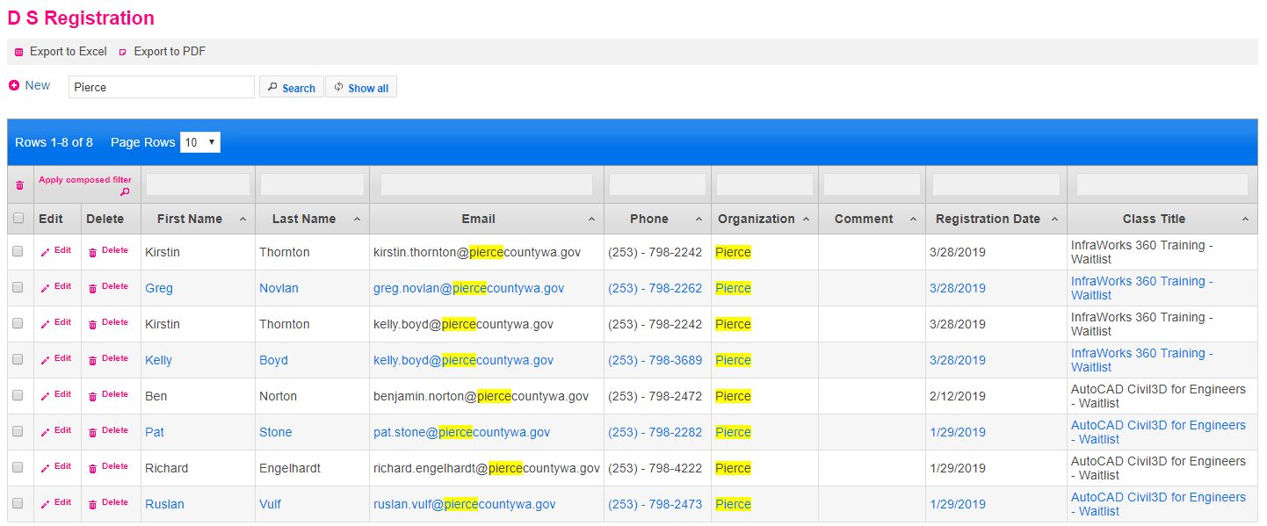

## Example “Apply composed filter” usage:

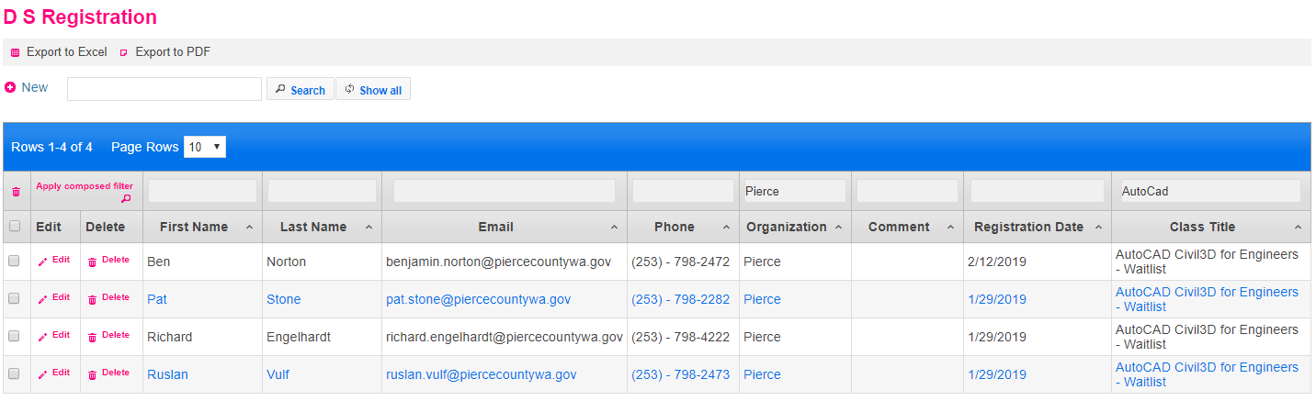

## Adding or Editing a Record:

-Whether you’re adding or editing, the concept is the same

-There is unfortunately very minimal capabilities when it comes to validation

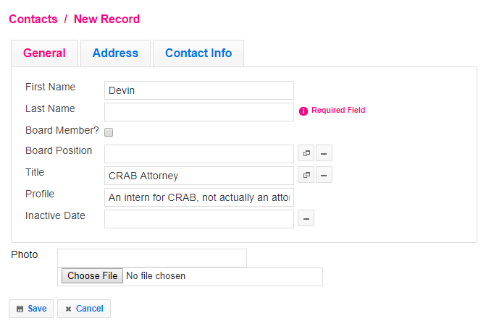

-Fill out the form as desired with information that matches the label. If a field is required, TSE will notify you if you attempt to Save the record

-In the case of fields that rely on data from another table (fields that have the circled button), click the button and find the desired record from the window it brings up (see InsertTabRelation for more info)

-In this example, a table using categorized tabs for the form is used. For tables like this, it isn’t immediately obvious when you’re missing a required field. If the Save button isn’t doing anything, be sure to check every tab

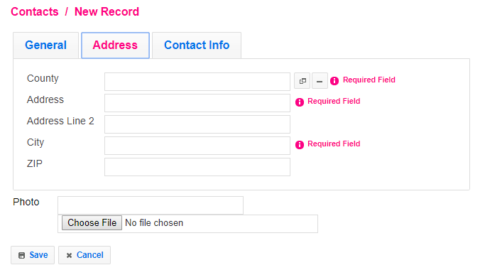

## File Uploading:

-Some tables (Worksheets, Board Meetings, and Contacts) have optional fields that allow you to upload a file to be associated with the fields (such as a photo for a contact)

-Board Meetings will allow .pdf, .xls, or .xlsx

-Workseets will allow .xls or .xlsx

 -Contacts will allow .jpg, .jpeg, .png, or .gif

-Click the “Choose File” button to bring up a generic window allowing you to choose a file

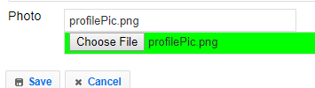-Upon confirming your file choice, the file upload control should turn green and show the uploaded file’s name, and the filename should also populate the textbox. If you choose an incorret file type (see above), it will be red instead of green and show an error

-Note that the file isn’t fully saved to the server until the “Save” button of the form is clicked

## ntext Data Type and Tiny HTML Text Editor:

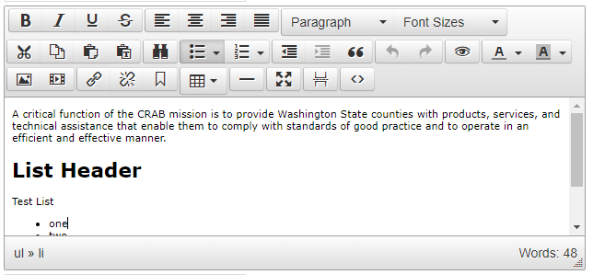-When working with columns in a table that have ‘ntext’ as their data type (for this project, this includes table that allows you to edit the content of a webpage), TSE will provide a Tiny HTML Text Editor on the forms for creating and editing a record

-This editor provides various styling options, similar to what you might see in Microsoft Word, and replicates HTML tags and styling once you save the form

-Using the provided image as an example: You can see it start off with a paragraph of basic text. Under that is larger, bold text. This was made by changing the drop down on the top (default “Paragraph”) to “Header 1”. Beneath that is some more basic text, with a bulleted list under it.

-For those reading with experience in HTML: When this is saved to the database, the initial paragraph is wrapped in a <p> tag. The large bold header is wrapped in an <h1> tag. The text above the list is wrapped in a <p> tag. And the bulleted list becomes a <ul> element with <li> elements for each member of the list. The bottom left of the editor will inform you of the current tag based on your text cursor’s location, including any parent tags, as shown in the image

-For those reading without HTML experience: Ideally all you need to know is that you can edit the content of the editor however you’d like, and the editor will apply the code necessary to make it show up on the web page as you’d expect

-Should you have an ntext column in a database that you don’t want TSE to apply the text editor to on the forms (since it will always wrap what you type with some sort of HTML tag), you may disable this with “DisableEditorTextArea” in Web.config. This was used for the default required TSE tables, but if you do not want the tiny HTML text editor in your own tables, then use of the ntext data type is strongly discouraged in the first place

# TSE Users:

-Everything regarding users for TSE are stored in the database it works with

## Users:

-Straightforward, simply input the desired username and password (**both case-sensitive**), any email (it’s a required field, but the password recovery feature does not work), and assign a User Profile (see below for more info) to the User (affects what they can and cannot see or do)

## User Profiles:

-Affects what a User with a given profile can and cannot see or do

-Unintuitive in that rather than adding specific permissions to a user profile, **a user profile can by default do everything, and you must take away permissions one-by-one**

-This is done through the various columns that “hide” and “disable” certain things

-“Main Menu” refers to tab groups (such as CMS Webpages or DS Training). Refer to them as named, spaces included

-“Menu Voice” refers to a specific table. Refer to a table with its name in the database, no spaces

-“Table Field” refers to a specific column of a specified table. Refer to it with *tableName.columnName*

-The three “disable” columns remove the buttons to add/edit/delete a record as you’d expect

-**NOTE:** In all cases, separate multiple values with a comma, and the last value must end with a comma, **even if there is only one value**

# Web.config:

-What seems to be the file intended to be the primary (or even only) file you're meant to edit for configuring TSE

-The file is largely commented with descriptions on what each feature does and how to set it up, but it can be vague and/or leave things out, so I will elaborate on key ones

## TabMenuVoices:

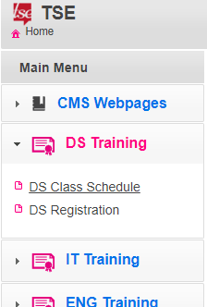-These are the drop-down groups seen along the left side of the page

-From what I can tell “Tab Menus” refer to the drop down lists, and the individual links are the “Voices”

-Voices default to the name of the table they link to. It will attempt to add spaces before capital letters to separate words (ie. TechPeopleTable becomes Tech People Table), but this can cause unpredictable results if you have multiple capital letters in a row

-Voices can have customized names however. The comments in the Web.config file provide an example, but isn’t very in-depth

-Custom voices are setup as: *custom name*##index.aspx?name=*tableName*&amp;mode=0&amp;tab=tabs-#

-The desired *custom name* requires no quotes, and spaces are allowed

-## is where the destination link starts. You can configure the link beyond this if you know what you’re doing, but this is all that’s necessary for our use

-“mode” is used by TSE to indicate the current “task”. 0 = table, 1 = new record form, 2 = edit record form, 3 = delete record form. In this case, you should always use 0

-“tab” is used by TSE to help it remember which Tab Menu should be dropped down between page navigation. Tab Menus are numbered in order from top to bottom, starting from 0 (start from 0 and skip no numbers, or unexpected behavior will occur)

-**TSE cuts off the last character of every custom menu voice**. This means you need a dummy character at the end. I used “x” for everything I added

-Example menu voice:

Other@puzzle.png,Board Meetings##index.aspx?name=BoardMeetingsCMS&amp;mode=0&amp;tab=tabs-5x,Contacts,Calendar;

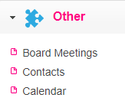-“Other” for Tab Menu title, puzzle.png used for its icon

-“Board Meetings” used as a custom Voice for BoardMeetingsCMS

-“mode=0”, show the table when we navigate here

-“tab=tabs-5x”, x added at the end to preserve the 5

-Contacts and Calendar simply referring to table names as they are acceptable as is, TSE by default will link to those tables

-As seen in the work I’ve done for TabMenuVoices in Web.config, you’ll see there is a lot of space between the different TabMenuVoices. This makes it easier to read, but this likely only works with TabMenuVoices. Failing to keep all values on the same line for any Web.config feature, or using more than one space (or any tab characters) between values (after ;), **can cause random Web.config functions to no longer work correctly.** I couldn’t tell you why.

## InsertTabRelation:

-TSE has no way to detect relationships between tables on the database, so you must indicate them here

-Fairly straightforward to pick up between what is already there, and the commented instructions on how to set it up

-This feature changes the foreign key field on the table and form for the “many” side of the relationship

-Example InsertTabRelation:

DS_Registration,DS_ClassID,DS_ClassSchedule,DS_ClassID,ClassTitle;

-Comments are misleading. It says “TabChild” for the second table, but the parent table (the “one” in a one-to-many relationship) is the second table

-DS_ClassID foreign key from DS_Registration, connecting to DS_ClassID primary key from DS_ClassSchedule

-Foreign key field on DS_Registration relies on “ClassTitle” column from DS_ClassSchedule to display data, instead of the matching integer of the PK/FK

-When working with the form of a “many” table of a relationship, the related field has two useful features: an autofill-esque one that shows the most relevant result as you type, and one that brings up the parent table by clicking a button and allows you to see every row to select the one you want

-**NOTE:** The autofill feature does not play nicely with the browser’s own autofill, particularly with addresses (ie. You select “Lacey” for a city and Chrome lets you autofill the other fields based on that, filling “Thurston” for your county). But if only plain text is in a TabRelation field, TSE won’t be satisfied. You must select a value from ITS OWN autofill, or using the insert-from-table button

-Autofill example:

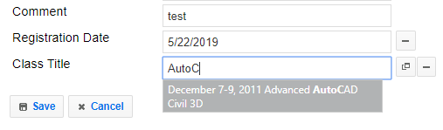

-Table example:

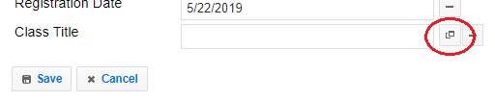

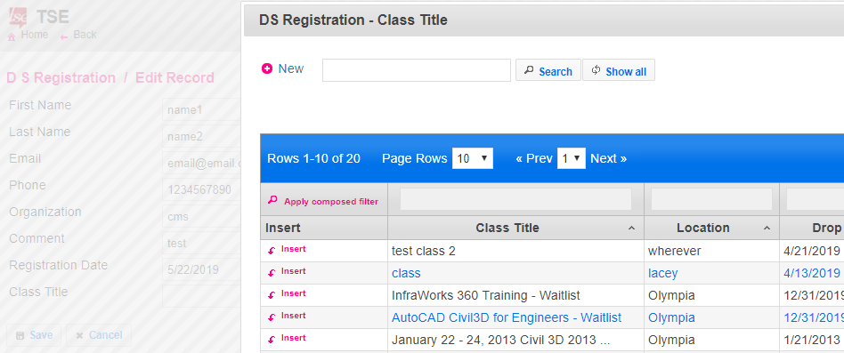

## TabsFormDati:

-Dati = Italian for “data”

-A handy feature that allows you to separate fields in a form into tabs. Useful for tables with a lot of fields to help them look more organized

-Example TabsFormDati: Contacts,$General,FirstName,LastName,IsCRABoardMember,BoardPositionID,TitleID,Profile,InactiveDate,$Address,CountyID,Address1,Address2,City,ZIP,$Contact Info,PrimaryPhone,PrimaryPhoneExt,SecondaryPhone,SecondaryPhoneExt,PrimaryCellPhone,SecondaryCellPhone,Fax,PrimaryEmail,SecondaryEmail;

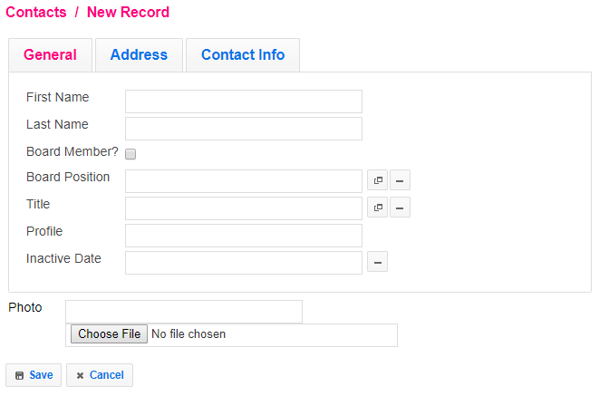

-Start with target table

-$*tab name* (spaces allowed), followed by every column you want to be apart of that tab

-Repeat for all desired tabs

-Any columns not assigned to a tab (Photo in this example) will still be included under the tabbed panels (file upload unrelated, added in backend code)

-**NOTE:** If TSE detects an invalid field, it won’t let you Save (as is intended) and will put errors next to the field in question. However, if this field is in a tab that isn’t active, it isn’t immediately clear what is wrong as you cannot see it. Custom JS can maybe fix this, but I don’t have the time

## Detail Table:

-Feature that can be added/configured in Web.config under DetailTable

-Connects two related tables, and displays a table of all child rows when in the form view of a parent row

-Example DetailTable: DS_ClassSchedule,DS_ClassID,DS_Registration,DS_ClassID,Registered for Class

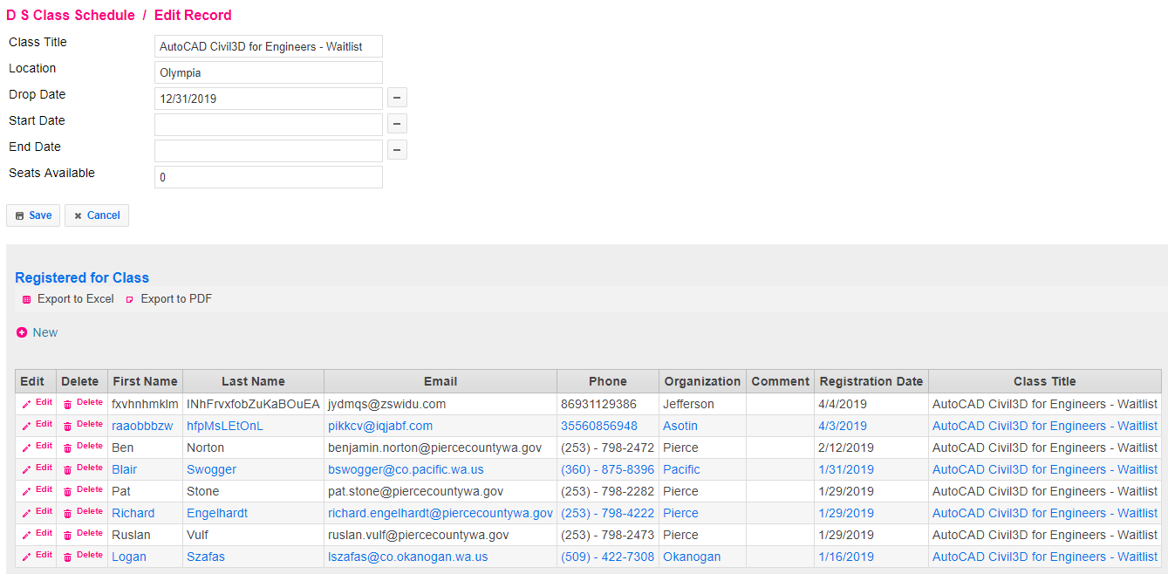

-Parent Table, PK ID Field, Child Table, FK ID Field, Desired caption to display

-TSE specifies that the two ID Fields must use the same name for this to work

-In this example, I went into the form view of a specific DS class by clicking Edit, and every person registered for the class is displayed in a table below the form

-From here, aside from seeing all child rows of the given record you’re on the Edit form for, you can also create new child rows and they will be associated with the record you’re editing (ie. clicking New in the list of people registered for this class would bring up another form that will let you add a new person to the Registration table, defaulting the class to the one you’re at)

-To make that work, this feature also requires you to use Web.config’s “DefaultFieldValue” feature (so that it can default the new child rows to the parent row you’re working from)

-This is explained in the Web.config file, but the DefaultFieldValue for the above example would be: DS_Registration,DS_ClassID,[DS_ClassID],newonly

-Parent Table, ID Field, [ID Field], newonly

-Note that DetailTable will also work when entering new records for the parent table, which I believe is unintended because the detail table below the form serves no purpose, and won’t let you make new child rows properly since you cannot set the value of the foreign key column

-As a result, the user should ignore the detail table whenever creating a new record

-The detail table can likely be hidden with some javascript (when on mode=1), but I do not have the time to implement this

## Brief overview of other noteworthy Web.config settings:

-ConnType – DBName and everything in between: Affects how TSE connects to the database

-FormFieldDescription: Adds text next to a specified field of a specified table on the form

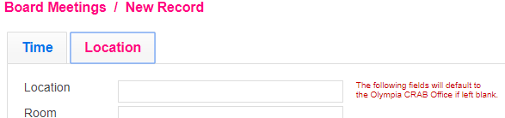

-PageDescription: Adds text to the header of a table’s page, can make purpose of a table more clear

-HideTableField: Hides specified fields of a table, useful for legacy fields

-HideFormField: Same as above, but on the form. Generally if you’re hiding a field in one place, you want to hide it on both (this doesn’t have to be the case however)

-DefaultFieldList: A theoretically useful feature that allows you to assign a drop-down to a field. Held back by how a data-source cannot be provided for it, and all choices must be manually entered here. Worth keeping in mind at least.

-FieldValidators: Supposed to help validate fields, but the only useful one it has is for Email. I also cannot get this to work with anything but the Email in the TSE Users table

-RenameLabelsFields: Renames column/label names on tables/forms to whatever you like. Useful if the column name in the database is weird or hard to read, or if TSE isn’t properly spacing on capital letters. Works on TabRelation columns/labels (simply rename the foreign key’s field name to whatever you want)

# Edited Files:

-Web.config: Primary file for configuring TSE

-Index.aspx: Added various JS functions for the sake of my own added upload feature, added timepicker for specific fields, added reference to a custom .css file, removed the ability to change bit fields directly on the table

-Index.aspx.cs: Added various methods and calls for the sake of my own added upload feature

-Search.aspx: Fixed autofill bug for TabRelation fields

-HtmlToPdf.aspx.cs: Configured the HtmlToPdf feature to actually work, changed some Italian-specific things

-timepicker.js: Changed some Italian-specific things

-date-en-US.js: Added myself (from datejs.com) to make formatting dates in javascript easier, as well as consistent with C#’s date formatting

# SQL Data Types Compatible with TSE:

-The following are SQL server data types that TSE is able to work with. Data types not present in this list will still show up on tables, but on the forms will simply display “Field type not managed”

* varchar
* nchar (worth noting that char is **not** supported but nchar is)
* nvarchar
* ntext
* bit
* smallint
* bigint
* int
* decimal
* numeric
* money
* float
* datetime
* date

# Bugs:

-"Apply composed filter" must be clicked, hitting the Enter key does not work

-"Apply composed filter" simply does nothing for some data types (smallint being one example, despite TSE supporting it)

-When entering a value for a date field for "Apply composed filter", a date **range** must be input despite this not being clear. There isn’t validation present if only a single date is entered, and the datepicker it uses returns a European formatted date (day/month/year). Still works if a date range (ie. month/day/year – month/day/year) is entered manually. If the datepicker format is fixed to return month/day/year, then it is able to return a valid range by selecting two dates

-Web.config eats the last character of values for custom urls (like for TabMenuVoices)

-For fields that might trigger a browser's autofill (such as a field a browser recognizes as associated with an address like "County"), the browser's autofill takes priority over TSE's. This is mostly an issue with foreign key columns as it prevents TSE from grabbing an associated row via autofill

-When using TabsFormDati (feature that separates form fields into different tabbed groups), if TSE detects an invalid field, it won’t let you Save (as is intended) and will put errors next to the field in question. However, if this field is in a tab that isn’t active, it isn’t immediately clear what is wrong as you cannot see it. Custom JS can maybe fix this

-FieldValidators (Web.config feature) seemingly only works on the "Email" field of TSE's Users table, even if additional values are entered

-The "forgot your password" feature needs to be setup so the email has somewhere to come from, this is done at the bottom of Web.config. I've simply hidden the button ("LostLoginPanel" in Web.config) for now

-TSE somehow bypasses default constraints present on the tables it works with (I assume by specifically inserting null). In order to emulate a default constraint, you must use a trigger instead. Alternatively, Web.config has a feature (“DefaultFieldValue”) that let’s you populate given fields with values of your choice. The form will have the fields already populated with the defaults, and the user can change them as desired (possibly better than the trigger I have in place for Board Meetings)

-Not much of a bug, but due to the extent of my changes, I find it hard to believe there won’t be merging issues if TSE devs push out an update, unless they ONLY change their .dll file